**SQL Job Preparation Assignment 4**

1. EMP TABLE'S 3 DYNAMIC COLUMNS SHOULD BE DISPLAYED. Instead of "Select EMP, SAL from EMP," your application should prompt you to choose the column you want to select at runtime.

Sol: - SELECT &First_column, &Second_column

FROM &Table_name;

There will be three pop-up windows asking for the column names.

Give first_column as EMP_NAME

Second_column as SAL

Table_name as EMP

2. Write a query to retrieve the data, and column names should be given at Runtime. Sort the query based on the first column.

Note: As we are hardcoding the name of the column, we cannot use "Order By EMP" as the Column name is not yet selected

Sol: -

SELECT &FIRST_COLUMN AS FIRST_COLUMN,

FROM EMP

ORDER BY FIRST_COLUMN;

I have created the DEPT table and when I run the query, I choose the ‘LOC’ and below is the result. As it has sorted the column based on the ascending order, and in table I have inserted the LOC in descending order.

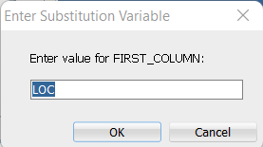

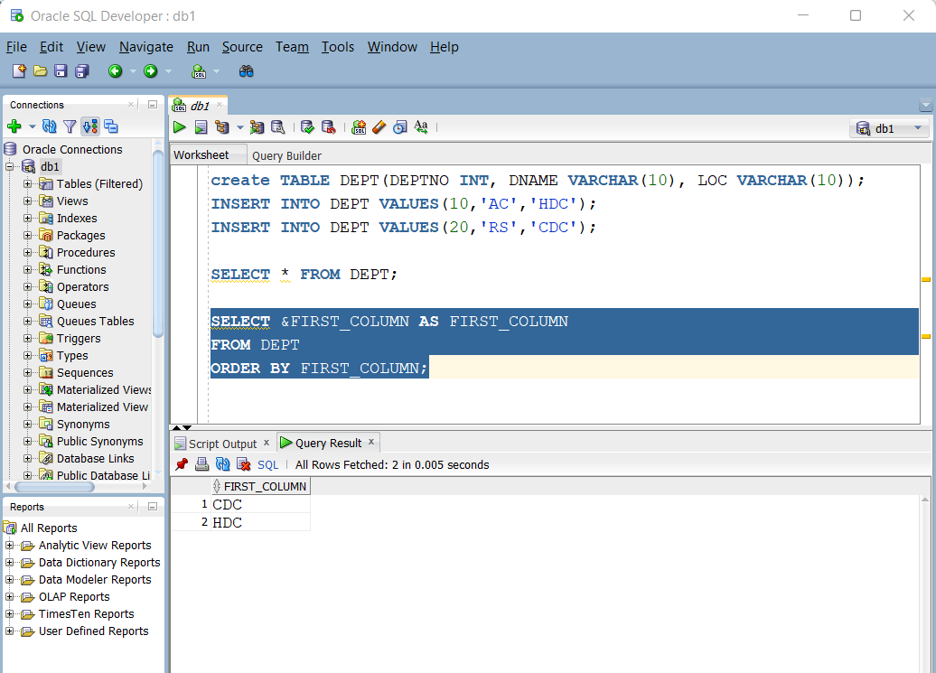

3. WHAT IS THE DIFF BETWEEN "&" AND "&&"?

Sol: -

& 🡪 will pop-up each time when the query gets run and ask input from user.

It can be used for the varying column, condition in query.

&& 🡪 will pop-up **only once** and take input from user and when the same query runs again then it will consider the input given in the first time of query run.

It can be used when we know that column, condition will not be changed in future while we run the query.

4. Write a query to demonstrate '&&' and '&' in a single statement.

Sol: -

SELECT &FIRST_COLUMN, &SECOND_COLUMN

FROM &&TABLE_NAME

WHERE &CONDITION;

I have used && to take the table name at runtime and it will ask only once when every we run the query.

& is used to take first_column and second_column names along with the condition when ever we run this query.

5. Write a Query for the below statements

Table DEPT:

------------------------------

DEPTNO DNAME LOC

10 AC HDC

20 RES CDC

------------------------------

Table DEPT1:

------------------------------

DEPTNO DNAME LOC

10 AC HDC

------------------------------

Use the SET operator to merge the above two tables; also, no repetition data should be there

Sol: -

SELECT DEPTNO, DNAME, LOC

FROM DEPT

**UNION**

SELECT DEPTNO, DNAME, LOC

FROM DEPT1;